Registration Form

Name:

Address:

Phone:
e-mail:

Special Needs:

Special Dietary Needs:

Housing:
Single $ 60 per night __________

Double $40 per night __________

I would like to room with

_______________________________

Meals:

Session 1: Friday dinner, Saturday breakfast, Saturday lunch.
Session 2. Saturday dinner, Sunday breakfast, Sunday lunch.
Session 1 $32.50 _________ Session 2 $32.50 _________

Housing/ Meals: TOTAL _________

Please send this form and your check by September 15 to:

Fran Rahn, Treasurer
St Andrew’s Church
555 East Third Street
Grove, OK 74344
530-559-1325

Checks written to:
ECW, Diocese of Oklahoma

Or, you may bring your check but first email your reservation to
Fran Rahn, franrahn@gmail.com
or Robin White, robin.a.white@usa.net
EVEN if you told someone else if you were coming!

NB. Please read, bring, and sign the attached Covid-19 waiver.

Women’s Getaway Retreat

October 2-4, 2020

Get me Out of Here!
This is an unstructured retreat to celebrate the ministry of The Rev. Debora L. H. Jennings and to take a break from our upside down world.

This retreat is sponsored by the Diocese of Oklahoma Episcopal Church Women.
Scholarships are available.

This retreat is very loosely structured with a few activities with optional attendance. It is chiefly designed as a time of quiet and reflection, remembering the unique ministry of The Rev. Debora L. H. Jennings

The retreat will be two days, commencing at 4 PM on Friday, 2 October. There will be six meals offered. We’ll be departing after lunch on Sunday, 4 October.

On Saturday morning Cheryl Allen will offer some short sessions focusing on Body and Spiritual Wellness.

Saturday afternoon will be a time of sharing memories and stories of our times with Mother Debora. We are planning a “Debora Jennings Memorial Hike” to the Labyrinth, Oklahoma weather permitting. An alternate indoor labyrinth is planned.

We are planning on fellowship time around the fire pit in the evenings, and some structured worship time: kayaking and Frisbee golf will be available. It is a time to gather and connect.

Remember: Be sure to bring paper, pen, journal, knitting, cards, and/ or puzzles. A good book is never a bad idea.

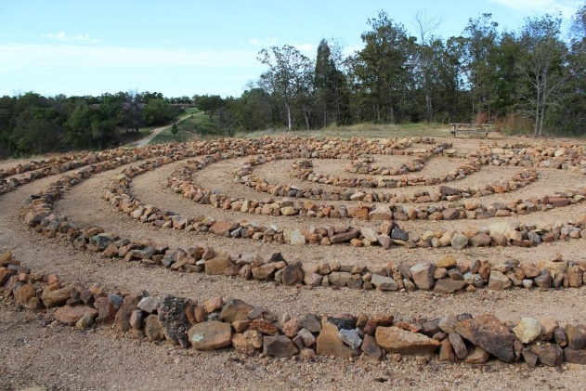

Bring comfortable clothing
and shoes.
Be ready for rain, snow, sunshine, cold rooms, warm rooms. . . .well you get the picture!!!!

St. Crispin

St. Crispin and his brother Crispinian were Martyrs of the Early Church who were beheaded during the reign of Diocletian;
the date of their execution is given as
25 October, 285 or 286.
When offered to save their lives by turning from Christ they said:

"Thy threats do not terrify us, for Christ is our life, and death is our gain.
Thy rank and possessions are nought to us, for we have long before this sacrificed the like for the sake of Christ and rejoice in what we have done.
If thou shouldst acknowledge and love Christ thou wouldst give not only all the treasures of this life,
but even the glory of thy crown itself
in order through the exercise
of compassion to win eternal life."

Their feast day is October 25th.
They are the patron saints of
saddlers, shoemakers, and tanners.

*****

Friends, during this time of anxiety and division in our country, may we, like Crispin, embody compassion, for the sake of the Gospel.
-Mother Debora+

